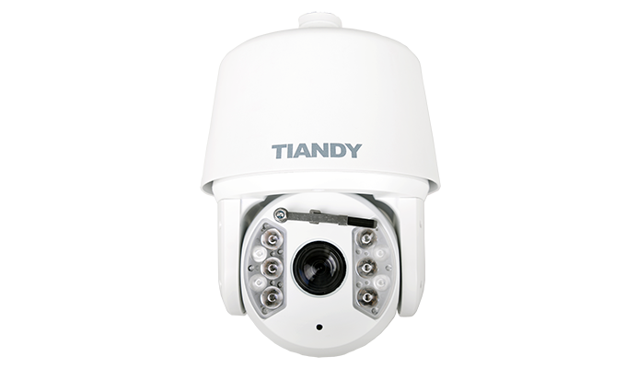

Features

• Up to 1920X1080 High Resolution  
• Full HD 1080P Video  
• Smart IR, IR Range: 180-200m  
• Speed: 0.05-400°/s, -11~90° Tilt Angle  
• Low Illumination 0.0002Lux @(F1.5,AGC ON)  
• Optical Zoom: 24x, Digital Zoom: 16x  
• WDR, 3D DNR, HLC, Dual-ICR  
• Triple Streams  
• On-board Storage, up to 64GB  
• Tripwire Detection  
• Perimeter Detection  
• Smart Defog  
• TVS 6000V, Lightning/Surge 4000V Protection  
• Temperature: -40°C-70°C

Specification

|  |  |
| --- | --- |
| Camera |  |
| Image Sensor | 1/1.8″ Sony Progressive Scan CMOS |
| Effective Pixels | 1920(H)x1080(V) |
| Signal System | PAL/NTSC |
| Minimum Illumination | Color: 0.002 Lux @(F1.5,AGC ON) |
| Black&White:0.0002Lux @(F1.5,AGC ON) 0 Lux with IR |
| White Balance | Auto/ ATW/ Manual |
| AGC | Auto/ Manual |
| S/N Ratio | ≥ 55dB |
| BLC | Y |
| HLC | Y |
| Smart Defog | Y |
| WDR | 100dB |
| Digital Noise Reduction | 3D DNR |
| Exposure Mode | Auto/ Manual/ Iris First/ Shutter First |
| Shutter Time | 1/25-1/10000S |
| Day& Night | Dual-ICR |
| Digital Zoom | 16x |
| Privacy Masking | 4 Privacy Masks Programmable; Optional Multiple Colors |
| Auto Focus | Auto/ Semi-automatic/ Manual |
| OSD | 16×16,32×32,24×24,48×48,64×64 Character Size Time/Date/Week/Character Superposition in 5 Regions PTZ Angle Superposition |
| Lens |  |
| Focal Length | 6.0-144mm, 24x |
| Zoom Speed | Approx.5s(Optical Wide-Tele) |
| Angle of View | 61.2°(w)~2.32°(t) |
| Minimum Working Distance | 6.0-180mm(Wide-Tele) |
| Aperture Range | F1.5-F4.3 |
| Pan & Tilt |  |
| Pan Range | 360° Endless |
| Pan Speed | Pan Manual Speed: 0.05° -400°/s, |
| Pan Preset Speed: 400°/s |
| Tilt Range | -11°-90° (Auto Flip ) |
| Tilt Speed | Tilt Manual Speed: 0.1°-120°/s, |
| Tilt Preset Speed: 200°/s |
| Proportional Zoom | Rotation Speed Can Be Adjusted Automatically According to Zoom Multiples |
| 3D Position | Y |
| Number of Preset | 256 |
| Scan | 8 |
| Cruise | 8, up to 32 Presets per Cruise |
| Pattern | 8, Each One With 180s Memory or 300 Orders |
| Power Loss Recovery | Y |
| Guard Action | Preset/ Cruise/ Pattern/ Scan |
| PTZ Position Display | Y |
| Freeze Frame | Y |
| RS-485 Protocols | PTZ_PELCO_D，PTZ_PELCO_P，PTZ_TC615_P，DOME_PELCO_D，DOME_PELCO_P，DOME_PLUS |
| Infrared |  |
| IR Irradiation Distance | 180-200m |
| IR Irradiation Angle | Adjustable by Zoom |
| Interface |  |
| Audio Input | 1-ch Mic in(Line in Interface) Line Input 2-2.4V[p-p]; Output Impedance 1KΩ, ±10% |
| Audio Output | Line Level, Impendance: 600Ω |
| Communication Interface | 1-ch RJ45 10M/ 100M Ethernet Interface and 1-ch RS-485 Interface |
| Alarm Input | 8-ch |
| Alarm Output | 2-ch |
| Video Output | 1.0Vp-p / 75Ω, NTSC (or PAL) Composite, BNC |
| On-board Storage | Built-in Micro SD/SDHC/SDXC Card Slot, up to 64 GB |
| Extension | N/A |
| Network |  |
| Ethernet | 10Base -T/100Base-TX RJ45 Connector |
| Max.Image Resolution | 1920×1080 |
| Main Stream | 50Hz 25fps(1920×1080), 25fps(1280×960), 25fps (1280×720) |
| 60Hz 30fps(1920×1080), 30fps(1280×960), 30fps (1280×720) |
| Sub Stream | 50Hz: 25fps(704×576), 25fps (352×288), 25fps (176×144) |
| 60Hz: 30fps(704×480), 30fps (352×240), 30fps (176×120) |
| Third Stream | 50Hz: 25fps (352×288), 25fps (176×144) |
| 60Hz: 30fps (352×240), 30fps (176×120) |
| Image Compression | H.264/MJPEG, H.264 Encoding with Baseline/Main/High Profile |
| ROI Encoding | Support 4 Areas with Adjustable Levels |
| Audio Compression | G711A/G711U/ADPCM/AAC |
| Protocols | IPv4/IPv6/ HTTP/ HTTPS/ 802.1x/ Qos/ FTP/ SMTP/ UPnP/ SNMP/ DNS/ DDNS/ NTP/ RTSP/ RTP/ TCP/ UDP/ IGMP/ ICMP/ DHCP/ PPPoE |
| No. of Simultaneous Users | Up to 2 Users |
| Mini SD Card | Manual REC/ Alarm REC. |
| User/Host Level | Up to 32 Users, 4 Levels |
| Security Measures | User Authentication (ID and PW), |
| Host Authentication (MAC Address) |
| IP Address Filtering |
| Web Browser | IE 7+, Chrome 18 +, Firefox 5.0 + |
| Advance |  |
| IVA | Tripwire, Perimeter |
| Intelligent Alarm | Motion Detection, Cover Alarm, Port Alarm, Network Disable Alarm, IP Conflict, MAC Conflict Detection |
| General |  |
| Language | English, Simple Chinese |
| Operating Conditions | -40°C-70°C, 0～95% RHG |
| Power Supply | AC24V 3A |
| Power Consumption | Max. 45W (IR ON OFF) |
| Circuit Protection | TVS 6000V, Lightning/ Surge 4000V Protection |
| Impact Protection | IP66 |
| Wiper | N/A |
| Dimensions | 230mmx332mmx230mm |
| Weight | 5.1KG (IP PTZ Only), 7.6KG (with Packing Box) |

Dimension

